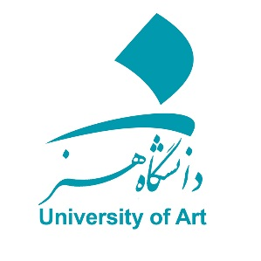
In the Name of GOD

MEMORANDUM OF UNDERSTANDING (M.O.U)
On
Educational, Research and Technological Cooperation

Between
University of Art, I. R. of Iran
And

-----------------------------

Recognizing the importance of academic, research and technological cooperation between universities and research centers for active engagement of academic members and researchers in the domain of science and technology and in order to expand the academic relationships, University of Art, (hereinafter called as University), no. 56, Sakhai St., Hafez ave., Tehran 1136813518, Iran, represented by Prof. Mohammad Reza Hosnaee (President), and ------------------------, (hereinafter called as ---------------) (---------------------------------- ) represented by ------------- (---------), (collectively hereinafter called as the "Parties") have reached as follows:

- To facilitate the exchange of academic members, researchers and experts for conducting research, teaching or exchange of ideas.

- To provide opportunities for professors and researchers to participate in conferences, symposia and international meetings of both parties.

- To provide necessary facilities to exchange professors to spend their sabbatical leaves in both parties.

- To collaborate in holding joint scientific, research and technological exhibitions and conducting joint research projects.

- To exchange students in the areas of mutual interest consistent with regulations of both countries.

- To exchange information, books, scientific publications, scientific and research documents, students' theses, microfilms and computer software in the educational, research and technological areas.

- To facilitate the visit of academic members, researchers, students of both parties.

- Financing any of the above-mentioned activities will be subject to mutual understanding.

- To execute of the any articles of this MOU both parties will set executive program on the basis of the mutual understanding.

- Any dispute over this MOU will be resolved through friendly negotiations and diplomatic channels between the parties.

- This present MOU will remain valid for Five years and may be renewed or terminated within six months written notices to the other party.

This MOU is done in 11 Articles, Dated in ……………………………..……
(solar year) corresponding to ……………………………..….... (Christian year) in the city of -------------------- in 2 copies, in (English) language. All of which are equally authentic and will come into force upon the signature at both parties.

For the University of Art,  Islamic Republic of Iran  Prof. Mohammad Reza Hosnaee  President | For -------------------  ----------------------  President

